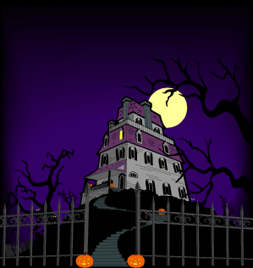

7:00 Open
Call to Order
7:30 Citizen Comments

7:35 Michelle Newcomb, Bartholomew & Co. - Investment of OPEB Trust Funds

7:55 Barbara Whitman, Rockland Trust Co. - Investment of OPEB Trust Funds

Approval of Minutes
Appointments
Old Business
New Business

- Joe Carty – Board of Registrars Appointment

- One Day License Request from the Silent Chef for 11/23/12

- Farm Licenses

Upcoming Meetings
Announcements
Adjournment
Executive Session

